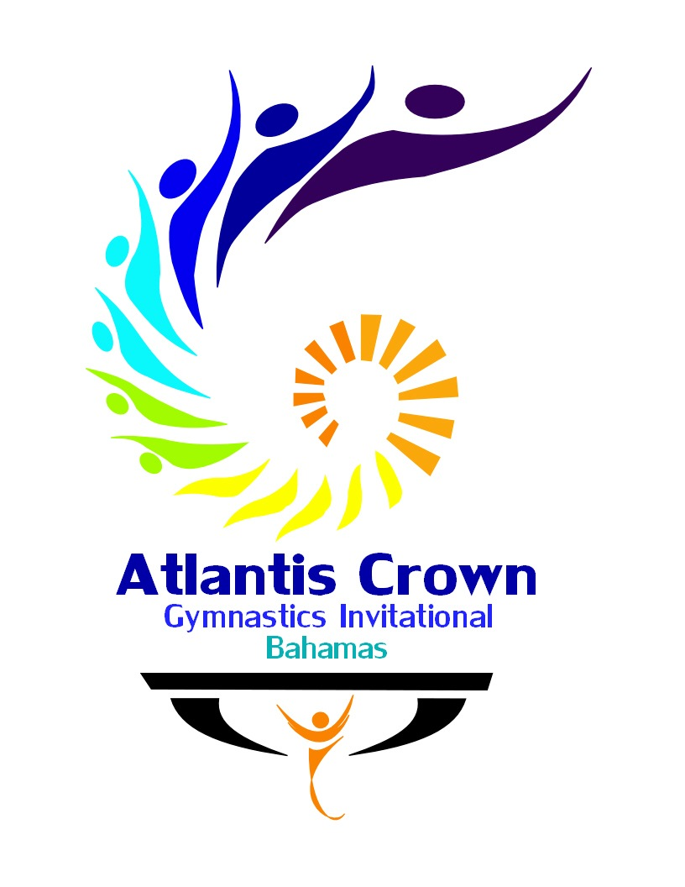

ATLANTIS CROWN GYMNASTICS TOURNAMENT

DELTA AIRLINES DISCOUNT DEAL

Delta Air Lines is pleased to offer special discounts for ATLANTIS CROWN

Please click here to book your flights!.

You may also call Delta Meeting Network® at 1.800.328.1111* Monday–Friday, 7:00 a.m. – 7:30 p.m. (CT) and refer to Meeting Event Code NMUV6
*Please note there is not a service fee for reservations booked and ticketed via our reservation 800 number.

Meeting Code – NMUV6

DISCOUNT TERMS:

The discount is available only to/from Nassau; and only during the travel period listed below. The amount of the discount depends on the specific fare class that’s available at the time.

Terms and Conditions:

Travel Period – December 7, 2021 – December 28, 2021

Blackout dates – None.

Advance Purchase – 14 days prior to departure.
Refunds/Reissues — Refunds are subject to rules of the fare purchased. Most fares are nonrefundable. For nonrefundable
fares, Delta may permit you to apply a portion of the fare value to future travel upon payment of applicable fees and fare
difference, otherwise the ticket will have no value. For refundable fares, refunds and changes are permitted per rules of fare
purchased. The discount is nonrefundable. Changes are subject to the rules of the fare purchased
and are subject to seat availability.

Transferability - Tickets are not transferable once issued.
Fares, schedules, offers and rules are subject to change without notice. Terms and conditions of this offer are as written and
cannot be altered, modified or waived unless authorized by a corporate officer of Delta Air Lines, Inc.

Baggage Fees – Standard baggage fees apply and are the responsibility of the passenger.

